Student worksheet: Bubble chamber pictures
Woithe, J., Schmidt, R., Naumann, F. (2018). Student worksheet & solutions: Bubble chamber pictures.
CC BY 4.0
A guide to analysing bubble chamber tracks including the following activities:
- Activity 1: How does a bubble chamber work?
- Activity 2: Electrically charged particles in magnetic fields
- Activity 3: Particle identification and properties
- Activity 4: Particle transformations
- Explanation puzzle pieces – cut out (to print on a separate sheet of paper)
- Worksheet solutions for teachers
Materials needed:
- 1 student worksheet per student
- Ruler
- Scissors
- Glue stick
- Pocket calculator

Where do the bubble chamber pictures come from?  This worksheet is based on images recorded by the 2 m bubble chamber at CERN on 10 August 1972. The bubble chamber was exposed to a beam of protons from CERN’s proton synchrotron PS with a momentum of 24 GeV/c. The magnetic field of 1.7 Tesla is pointing out of the page for all images. This bubble chamber was  2 m long, 60 cm high, and filled with 1150 litres of liquid hydrogen at a temperature of 26 K (-247°C). After its closure, this bubble chamber has been donated to the Deutsche Museum in Munich. The original pictures as well as the pictured with coloured tracks can be found online: https://cds.cern.ch/record/2307419 | 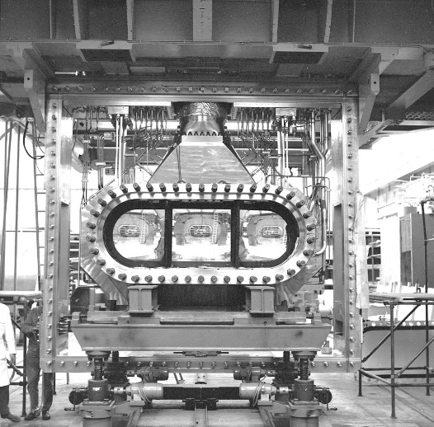  Main body of the 2 m Bubble Chamber  © CERN

Activity 1: How does a bubble chamber work?
A large cylinder is filled with a liquid at a temperature just below its boiling point. Then, the pressure inside the cylinder is lowered by moving a piston out to increase the chamber volume. In this way, the liquid enters a metastable phase, the so called superheated state. Any disturbance will now cause the creation of bubbles when parts of the liquid enters the gaseous state. High-energy electrically charged particles leave a track of ionized molecules when penetrating the chamber. These ions will trigger the vaporization process, and a line of bubbles will form along the particle track. Once the newly formed bubbles have grown large enough, cameras mounted around the chamber capture the event. Afterwards, the piston is moved inwards again to increase the pressure and get rid of the produced bubbles to make the chamber ready for the next particles. A magnetic field penetrates the chamber to allow momentum measurements through the radius of curvature of the deflected particle tracks.
a) Connect the name of each component with the correct description.
Component |  |  | Description
a piston | O | O | takes pictures of the bubbles created in the chamber (1)
b liquid | O | O | is used to change the pressure of the liquid (2)
c camera | O | O | enter the chamber when the liquid is superheated (3)
d magnetic field | O | O | is responsible for the curvature of the tracks (4)
e particles | O | O | provides particles (e.g. protons) with which the beam particles collide (5)
b) Describe the difference between the two pictures below and explain why both phases are needed to operate a bubble chamber.
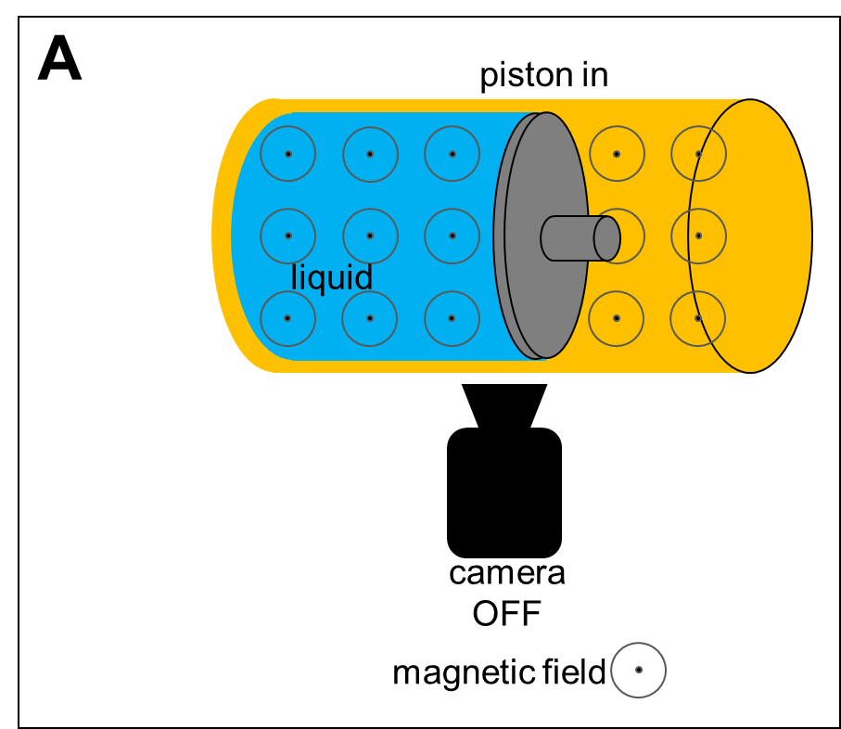 | 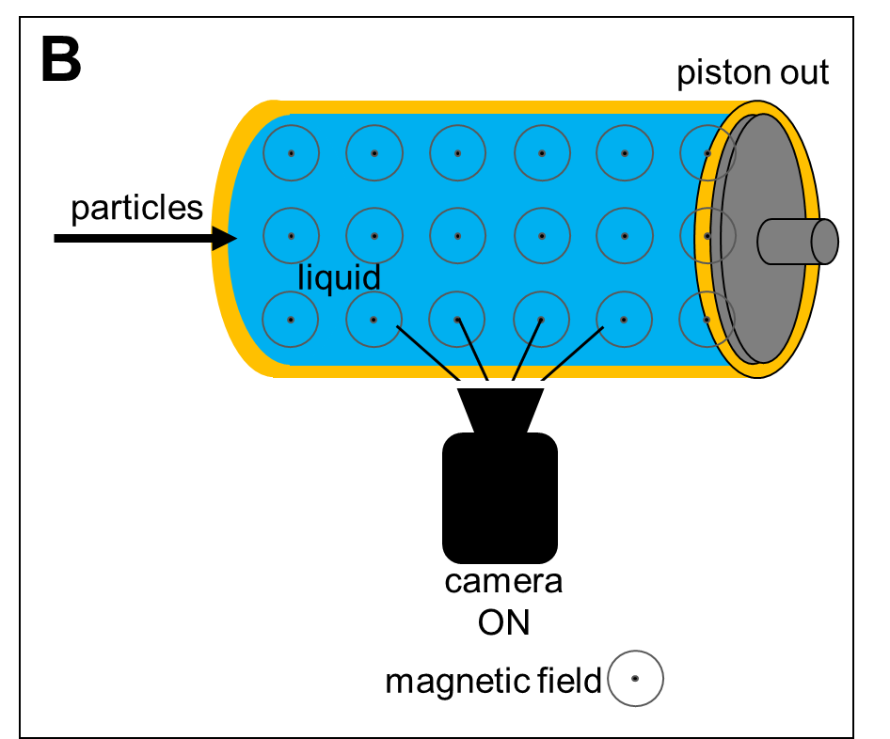
_________________________________________________________________________________________
_________________________________________________________________________________________
_________________________________________________________________________________________
_________________________________________________________________________________________
_________________________________________________________________________________________
REMINDER: Magnetic field lines are used to visualize the direction of magnetic fields. Derived from the shape of an arrow, the symbols below are used if the magnetic field is perpendicular to the page:
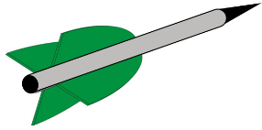 |  | Magnetic fields points into the page |  | Magnetic fields points out of the page
Activity 2: Electrically charged particles in magnetic fields
When electrically charged particles move through a magnetic field, they are deflected due to the Lorentz force. The right (or left) hand rule tells you, in which direction the Lorentz force points. The radius of curvature of the tracks is proportional to the particles’ momenta.
Right-hand rule for electrically positively charged particles
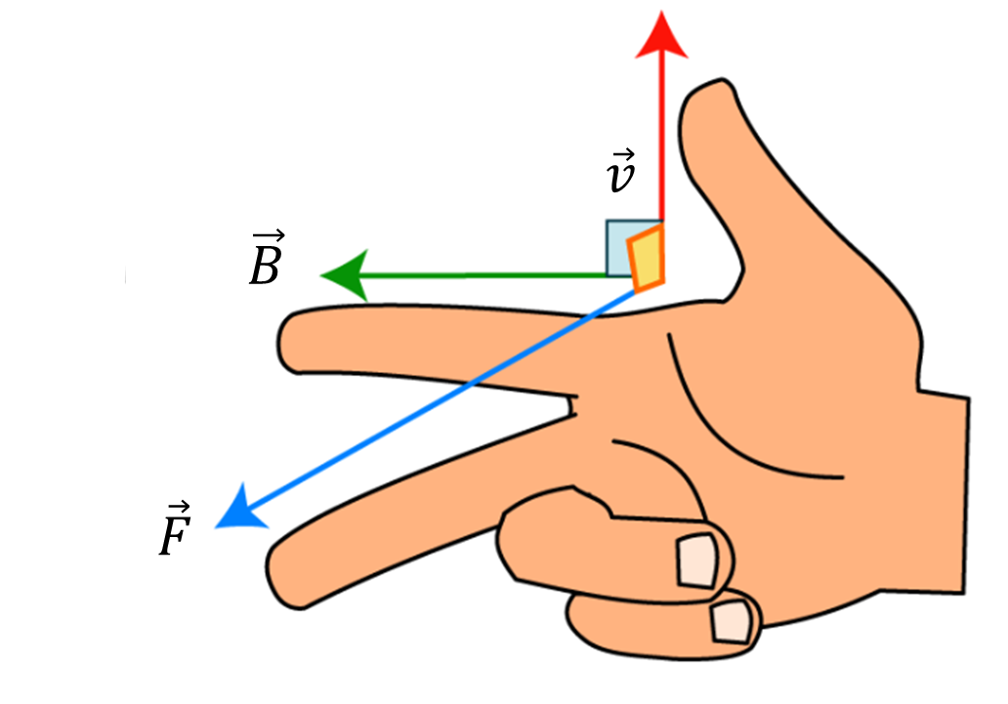 | $\vec{v}$ … velocity of the electrically positively charged particle
 | $\vec{B}$ … Magnetic field (from North to South)
 | $\vec{F}$ … Force on the electrically positively charged particle
Left-hand rule for electrically negatively charged particles
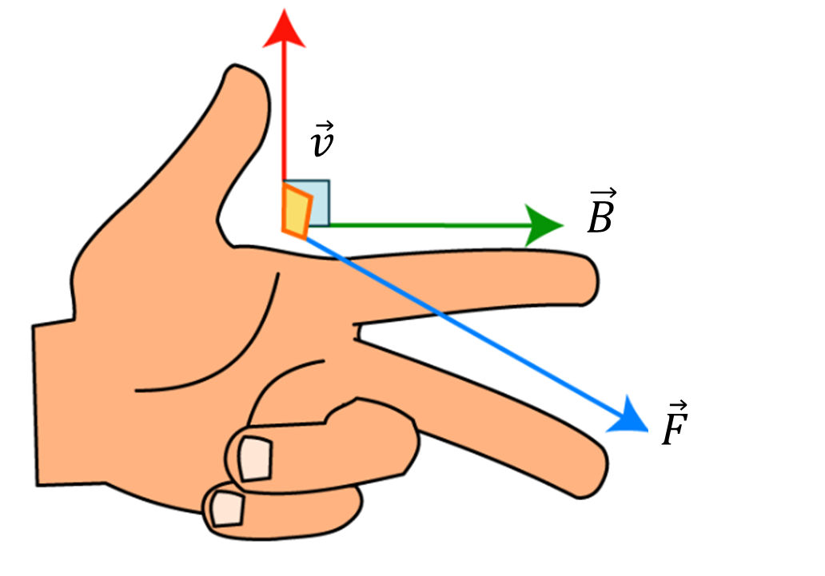 | $\vec{v}$ … velocity of the electrically negatively charged particle
 | $\vec{B}$ … Magnetic field (from North to South)
 | $\vec{F}$ … Force on the electrically negatively charged particle
a) In the picture below you can see a real picture of a bubble chamber. Two of the tracks are highlighted in red and blue to help you analyse the tracks. The particle beam enters the chamber from the left. The magnetic field points out of the page.
Which of the two coloured tracks belongs to a positively charged particle? _____________________________
Which of the two coloured tracks belongs to a negatively charged particle? _____________________________
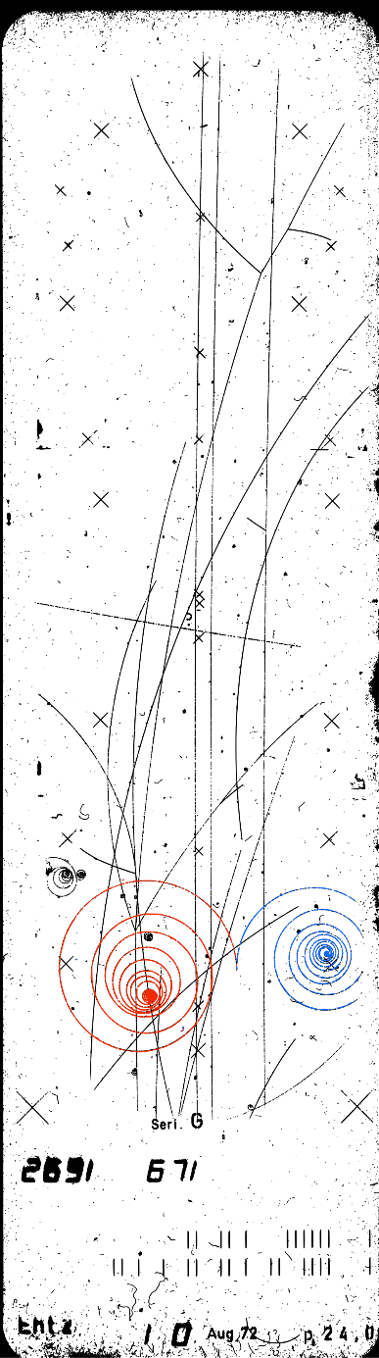

b) Why do these particles leave spiral tracks? ____________________________________________________
_________________________________________________________________________________________
_________________________________________________________________________________________
_________________________________________________________________________________________
_________________________________________________________________________________________
_________________________________________________________________________________________
c) Which of the tracks in the picture below belong to negatively charged particles?
(The particle beam enters the chamber from the left. The magnetic field points out of the page.)
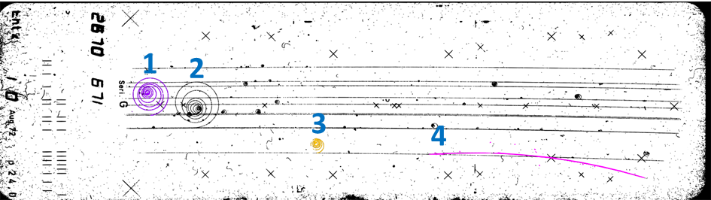
_________________________________________________________________________________________
_________________________________________________________________________________________

d) Assume, that all tracks which belong to negatively charged particles in the picture above are caused by the same particle type, electrons. Sort these tracks according to the particles’ momenta and explain your results.
_________________________________________________________________________________________
_________________________________________________________________________________________
_________________________________________________________________________________________
_________________________________________________________________________________________
_________________________________________________________________________________________
_________________________________________________________________________________________

Activity 3: Particle identification and properties
Different types of particles leave different signatures in a bubble chamber due to their electric charge and their mass. In the following images, the particle beam enters the chamber from the left (). The magnetic field points out of the page ().
a) Cut out the explanation puzzle pieces on page 9 and assign them to the correct picture of a track.
Bubble chamber track  (coloured for better visibility) |  |  | Identified particle | Interaction process and particle signature in a bubble chamber
Picture 1 | 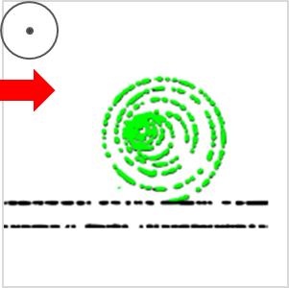
Picture 2 | 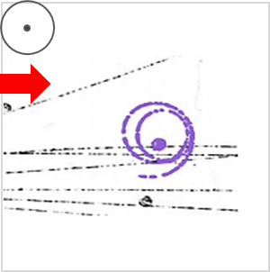
Picture 3 | 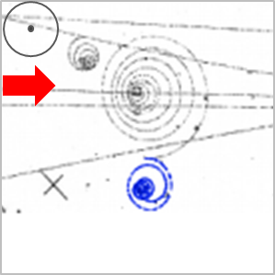
Picture 4 | 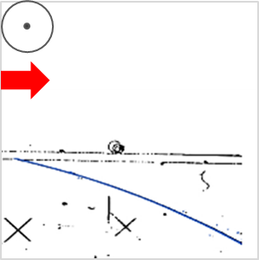
b) Identify the coloured tracks in the picture below:
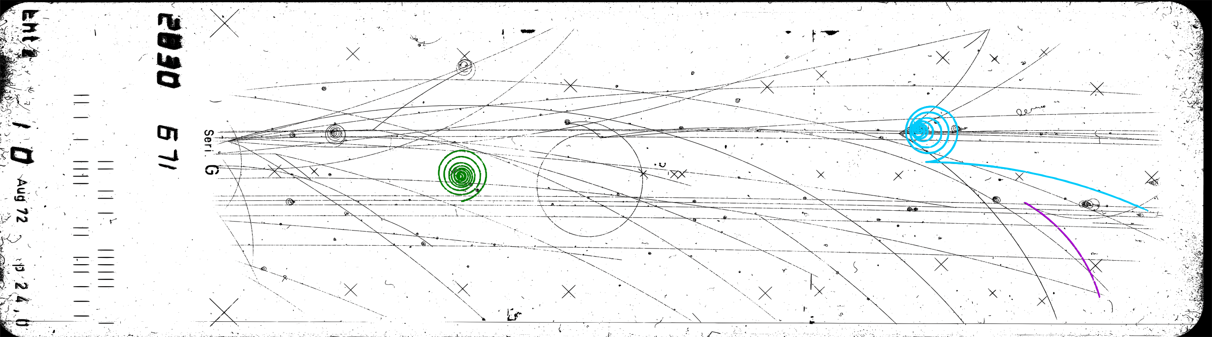
 | electron | positron | proton | explanation
green track | □ | □ | □
upper blue track | □ | □ | □
lower blue track | □ | □ | □
purple track | □ | □ | □

c) Which process was responsible for the two blue tracks? Explain!
_________________________________________________________________________________________
_________________________________________________________________________________________
d) Which of the two blue tracks belongs to the particle with the higher momentum? Explain!
_________________________________________________________________________________________
_________________________________________________________________________________________
e) Use a ruler to estimate the following measures.
Radius of curvature of upper blue track in m: $r_{image}=$______________
Length of the visible area in m: $l_{image}=$______________
In reality, the visible area of this bubble chamber was 2 metres long, what was the real radius of curvature of the upper blue track?
_________________________________________________________________________________________
_________________________________________________________________________________________
$r_{real}=$______________

f) Particle physicists at CERN determined the radius of the tracks in a similar way, and used this value to calculate the momentum of the particle which caused the track. Use the following formula below to calculate the momentum of the upper blue track: $p=q∙r∙B$
$$p … \left(relativistic\right) momentum of the particle$$$q$ … electric charge of particle in C | $B$ … Magnetic field strength in T  $r$ … radius of curvature of the particle track in m

_________________________________________________________________________________________
_________________________________________________________________________________________
_________________________________________________________________________________________
_________________________________________________________________________________________
_________________________________________________________________________________________
_________________________________________________________________________________________
_________________________________________________________________________________________
_________________________________________________________________________________________
_________________________________________________________________________________________
_________________________________________________________________________________________
g) In the bubble chamber pictures you have seen so far, the particle beam entering the chamber from the left consisted of protons. Many of these protons don’t interact with the liquid and just fly straight through the chamber. These protons have been accelerated in a particle accelerator at CERN called “proton synchrotron”. Their momentum when entering the chamber was $p=24 \frac{GeV}{c}$, the magnetic field strength in this bubble chamber was $B=1.7 T$. Calculate the expected radius of the curvature of the beam proton tracks using the formula below. Can you see the curvature of the proton tracks in the picture with your bare eyes?
$r=\frac{p}{q∙B}$ $1\frac{ eV}{c}=\frac{1.6∙{10}^{-19}J}{3∙{10}^{8} \frac{m}{s}}$
_________________________________________________________________________________________
_________________________________________________________________________________________
_________________________________________________________________________________________
_________________________________________________________________________________________
_________________________________________________________________________________________
f) Can you think of a reason why modern particle detectors are much bigger?
_________________________________________________________________________________________
_________________________________________________________________________________________
_________________________________________________________________________________________
Activity 4: Particle transformations
You have learned how to recognize the tracks of electrons, protons, and positrons in the cloud chamber. However, many more different types of particles are produced when high-energy particles such as protons interact with the liquid in a bubble chamber. Many of the produced particles are not stable, but they transform into other particles after a certain time. In this task, you will analyse two of these transformation processes based on the picture below. As usual, the particle beam enters the chamber from the left. The magnetic field points out of the page, and we used colours to help you identify the relevant tracks.
a) The green track belongs to a particle system called pion. There are three types of pions:
- $π^{+}$ (positive electric charge, particle system of an up quark and an anti-down quark $u\overline{d}$)
- $π^{-}$ (negative electric charge, particle system of an anti-up quark and a down quark $\overline{u}d$)
- $π^{0}$ (no electric charge, particle system of a mix (“superposition”) of $u\overline{d}$ and $\overline{u}d$)
Which type of pion caused the green coloured track? Explain!
_________________________________________________________________________________________
b) At the end of the green coloured tracks, the pion transforms into two new particles, a positively charged anti-muon and a muon-neutrino: $μ^{+}+ν_{μ}$ . Why do we only see one track (the blue coloured track) originating from the end of the green track?
_________________________________________________________________________________________
_________________________________________________________________________________________
c) How can we be sure, that a second particle was produced in this transformation process?
_________________________________________________________________________________________
_________________________________________________________________________________________
_________________________________________________________________________________________
d) The anti-muon (blue coloured track) tranforms into a particle you should be able to recognize. Which particle caused the brown coloured track? Explain!
_________________________________________________________________________________________
_________________________________________________________________________________________

Explanation puzzle pieces – cut out
Positron | Process: A photon transforms into an electron-positron pair.  Signature: downwards curved track starting “out of nowhere” together with an upwards curved track (electron), the photon does not leave a track
Electron | Process: An electrically charged particle enters the chamber and interacts with an electron in the liquid.  Signature: upwards curved track starting at a visible track of a beam particle
Proton | Process: An electrically charged particle enters the chamber and interacts with a proton in the liquid.  Signature: downwards curved track starting at a visible track of a beam particle.
“Compton electron” | Process: Compton-Scattering: A photon interacts with an electron in the liquid, part of the energy of the photon is transferred to the recoiling electron.  Signature: upwards curved track starting “out of nowhere”

Worksheet solutions
Activity 1: How does a bubble chamber work?
1. a) a & (2), b & (5), c & (1), d & (4), e & (3)
1. b) In picture A, the piston is moved into the chamber to increase the pressure of the liquid. In this state, the liquid will not boil, therefore no bubbles would be produced if particle enter the chambers.
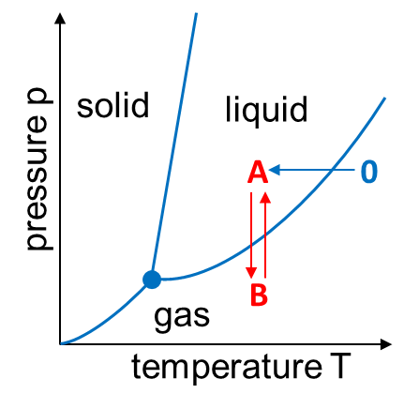
In picture B, the piston is moved out of the chamber to expand the volume and to reduce the pressure of the liquid. This leads to the superheated state of the liquid, any disturbance will cause gas bubbles to form. When high-energy electrically charged particles enter the chamber, they leave a track of ionized molecules. These ions will trigger the vaporization process, a line of bubbles will form along the particle track. The higher the energy loss per length, the higher the bubble density in the chamber. Once the newly formed bubbles have grown large enough, cameras mounted around the chamber capture the event. Afterwards, the piston is moved inwards again to increase the pressure and get rid of the produced bubbles to make the chamber ready for the next particles.
The phase diagram on the left shows the transition between phases A and B. Phase 0 shows the state of the hydrogen in the bubble chamber before beeing cooled down to 26 Kelvin.
Activity 2: Electrically charged particles in magnetic fields
2. a) Particle direction: from left to right, magnetic field direction: out of the page
- red track = Lorentz force pointing upwards = negatively charged particle
- blue track = Lorentz force pointing downwards = positively charged particle
2. b) On their way through the liquid, particles constantly loose energy because of the ionisation processes and Bremsstrahlung. A lower momentum corresponds to a smaller track radius in a magnetic field:
- In the bubble chamber, the Lorentz force $F_{L}=q∙v∙B$
- acts as centripetal force $F_{c}=γ∙m∙\frac{v^{2}}{r}$ (with $γ= \frac{1}{\sqrt{1-\frac{v^{2}}{c^{2}}}}$ for relativistic particles).
- Therefore: $q∙v∙B=γ∙m∙\frac{v^{2}}{r}$
- $⇒r=\frac{γ∙m∙v}{q∙B}=\frac{p}{q∙B}$ or $p=q∙r∙B$.
$q$ … electric charge of particle in C  $v$ … speed of particle in m/s  $c$… speed of light in vacuum in m/s | $B$ … Magnetic field strength in T  $m$ … mass of particle in kg  $r$ … radius of curvature of the particle track in m  $p$ … (relativistic) momentum of the particle
2. c) Tracks 1, 2 and 3 belong to electrically negatively charged particles.
2. d) From high momentum to low momentum: track 2 – track 1 – track 3 (the lower the momentum of the particle, the smaller the radius of curvature of the track)

Activity 3: Particle identification and properties
a)
Bubble chamber track  (coloured for better visibility) |  |  | Identified particle | Interaction process and particle signature in a bubble chamber
Picture 1 |  |  | Electron | Process: An electrically charged particle enters the chamber and interacts with an electron in the liquid.  Signature: upwards curved track starting at a visible track of a beam particle
Picture 2 |  |  | “Compton electron” | Process: Compton-Scattering: A photon interacts with an electron in the liquid, part of the energy of the photon is transferred to the recoiling electron.  Signature: upwards curved track starting “out of nowhere”
Picture 3 | 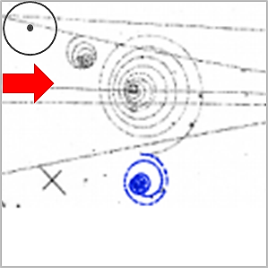 |  | Positron | Process: A photon transforms into an electron-positron pair.  Signature: downwards curved track starting “out of nowhere” together with an upwards curved track (electron), the photon does not leave a track
Picture 4 |  |  | Proton | Process: An electrically charged particle enters the chamber and interacts with a proton in the liquid.  Signature: downwards curved track starting at a visible track of a beam particle.

3. b)
 | electron | positron | proton | explanation
green track | x | □ | □ | Upwards curved track
upper blue track | x | □ | □ | Upwards curved track
lower blue track | □ | x | □ | downwards curved track appearing together with an electron track
purple track | □ | □ | x | downwards curved track starting at a beam particle track

c) Pair creation: A high-energy photon transforms into an electron-positron pair. The minimum energy of the photon is given by the rest energy of the positron and electron:
$$E_{photon}>E_{0, positron }+E_{0, electron }=2∙511 keV$$
d) The positron had a higher momentum, because the radius of curvature of the lower blue track is higher.
e) Values are only rough estimations and might differ depending on the print size
- $r_{image}=3.5 mm=0.0035 m$ (approximation, depends on the print)
- $l_{image}=$12.5 cm = 0.125 m (length of the longest visible tracks in the image)
- $l_{real}=2 m$ (the 2m bubble chamber was 2 m long)
- $⇒r_{real}≈0.056 m$
f)
$$p=q∙r∙B=1.6∙{10}^{-19}C∙0.056m∙1.7T=1.5∙{10}^{-20}\frac{kg∙m}{s}$$
$$1\frac{eV}{c}=\frac{1.6∙{10}^{-19} J}{3∙{10}^{8 }m∙s^{-1}}⇒p=28 \frac{MeV}{c}$$

The use of $\frac{MeV}{c}$ as unit of momentum is very common in high-energy physics, for the classroom this can be optional.
g)
$$r=\frac{p}{q∙B}=\frac{24 ∙{10}^{9}\frac{1.6∙{10}^{-19}J∙s}{3∙{10}^{8}m}}{1.6∙{10}^{-19}C∙1.7 T}=47 m$$
It is impossible to see the curvature of the beam protons in a 2 m long bubble chamber, their momentum is too high, and therefore, the radius of curvature of their tracks is much larger than the dimensions of the chamber.
f) One reason to build bigger detectors such as the 46 metres long ATLAS detector is the need to measure the particles’ momenta (especially the momenta of high energy muons) as precisely as possible. Although computer algorithms determine the radius of curvature in modern detectors instead of our eyes, they still require a certain minimum curvature to precisely measure the radius.
Another option would be to increase the magnetic field strength.

Activity 4: Particle transformations
${π^{+}→μ}^{+}+ν_{μ}$ ; $μ^{+}→e^{+}+ν_{e}+\overline{ν_{μ}}$
a) The green coloured track was caused by a positively charged particle, because it is curved downwards in the magnetic field. Therefore, we can identify it as $π^{+}$.
b) Neutrinos don’t have electric charge, which means they cannot ionise the molecules in the chamber. Therefore they won’t leave visible tracks.
c) Because of momentum conservation: If the pion would transform into only one new particle, the new particle should move in exactly the same direction as the pion. But we can see a kink, therefore, there must have been at least one additional neutral particle.
d) The brown coloured tracks was caused by a positron, easy to recognise because of its downward curved track. However, so far we have only seen positron tracks together with electron tracks caused by a pair production process caused by a high-energy photon.
If you are interested in the details of this transformation process including the relevant Feynman diagrams, have a look at: Woithe, J., Wiener, G. J., & Van der Veken, F. F. (2017). Let’s have a coffee with the Standard Model of particle physics!. Physics Education, 52(3), 034001. http://iopscience.iop.org/article/10.1088/1361-6552/aa5b25/ and the information below:
${π^{+}→μ}^{+}+ν_{μ}$ This process can be interpreted using Feynman diagrams as follows:
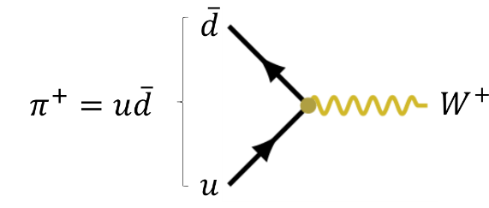 | The up quark and the anti-down quark of the pion annihilate to a virtual W⁺ boson.
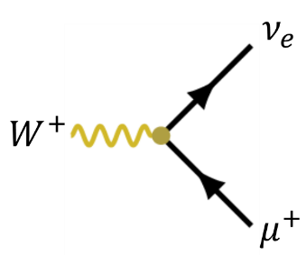 | The virtual W⁺ boson transforms into an anti-muon and a muon-neutrino.
$μ^{+}→e^{+}+ν_{e}+\overline{ν_{μ}}$ This process can be interpreted using Feynman diagrams as follows:
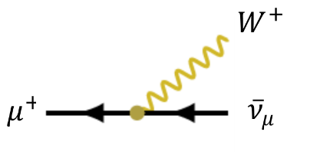 | The anti-muon transforms into an anti-muon-neutrino while emitting a virtual W⁺ boson.
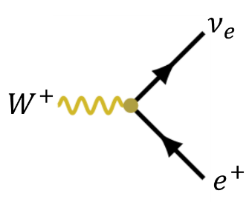 | The virtual W⁺ boson transforms into an positron and an electron-neutrino.

Additional resources
- A very impressive demonstration of superheated liquids can be produced when microwaving pure water in a mug or beaker glass with a very smooth surface. It is too dangerous for the classroom, but a great YouTube video is available from Time Warp: Exploding Water
- This broad collection of applets created by The King's Centre for Visualization in Science, Canada can help visualising concepts of modern physics including a simulation of electrically charged particle in magnetic fields and a simulation of a cloud or bubble chamber.
- BC site: an extensive collection including an online introduction to bubble chamber pictures, many images, and many practical exercises developed together with numerous teachers at CERN under the direction of Gron Tudor Jones
- A great article about bubble chambers with more detailed and more advanced calculations and a very advanced bubble chamber simulation by Michel Gagnon
- More educational, and very accessible online bubble chamber exercises by Peter Watkins

